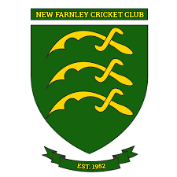

**Diary Dates**

**New Farnley can proudly announce that we are delighted to be hosting two One Day Internationals at The Barry Jackson Ground in 2024**

|  |  |
| --- | --- |
|  | **Jersey**  **vs**  **Zimbabwe A**  **50 Overs**  **11:00am Start** |
|  | **Jersey**  **vs**  **Zimbabwe A**  **45 Overs**  **10:00am Start** |
| **2021 – ECB Bradford Cricket League**  **Tom Mathers Ground of The Year - Winners** | |